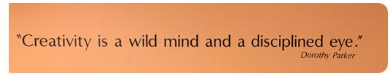
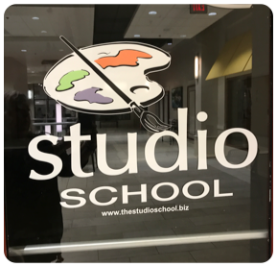
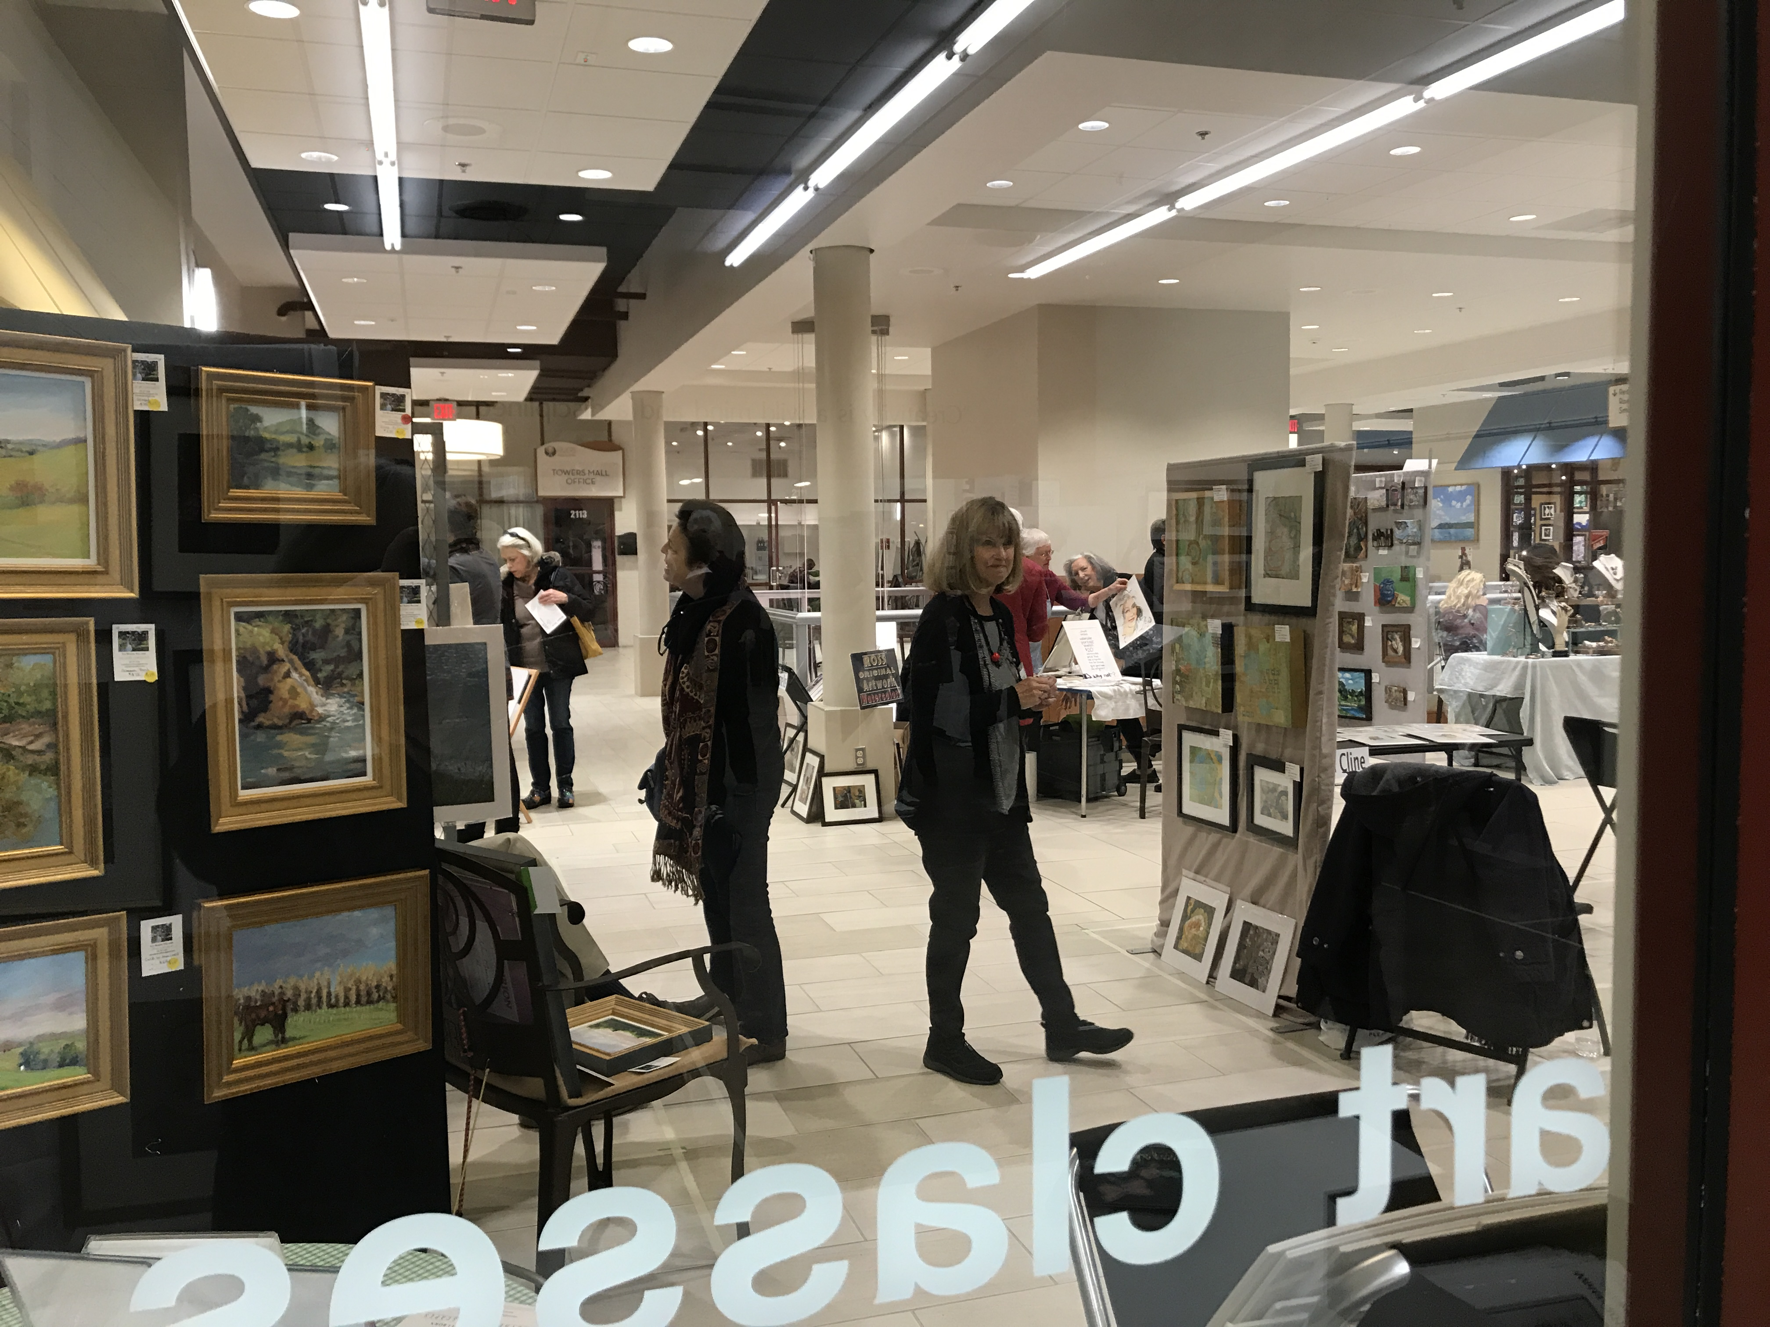
Easel Society Newsletter
January 2009
The ‘New’Art Blast was a fantastic success!
November 2018 marked the Studio School’s first indoor Art Blast! The show started with a Pre-view Party and Pre-sale event as our open house! A special thanks to all of the artists showcasing their work and to the patrons that came to take a peek!
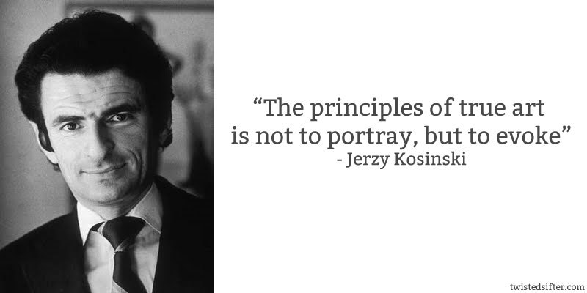
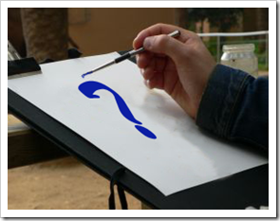
How to Overcome Artist Creative Block and Get Inspired.
Examine your culture.
Reminisce about early childhood.
Consistently use an artist sketchbook. Thing, drawing or painting a day.
Create numerous artworks simultaneously.
Look at the art of other artists online and at art galleries.
Try out a new artistic medium.
Watch a Netflix film about an artist.
Spend 5 minutes doing a quick gesture drawing or doodle
Go to http://artprompts.org and choose a promt
Listen to a song or read a short story;draw it.
Feeling inspired can be tough at times, especially for artists who have a 9-5 job outside of art. We may be too tired to think straight, or distracted by our daily routine. In such situations, we have to search for sources of inspiration and creativity.

Inspiration ideas are all around us – everywhere an artist ventures, who they speak with, what they experience, and everything an artist does outside of the art field.

Whether you are experiencing artists block, or just need some ideas on where to look for artistic inspiration here are a few ideas that may be inspiring:
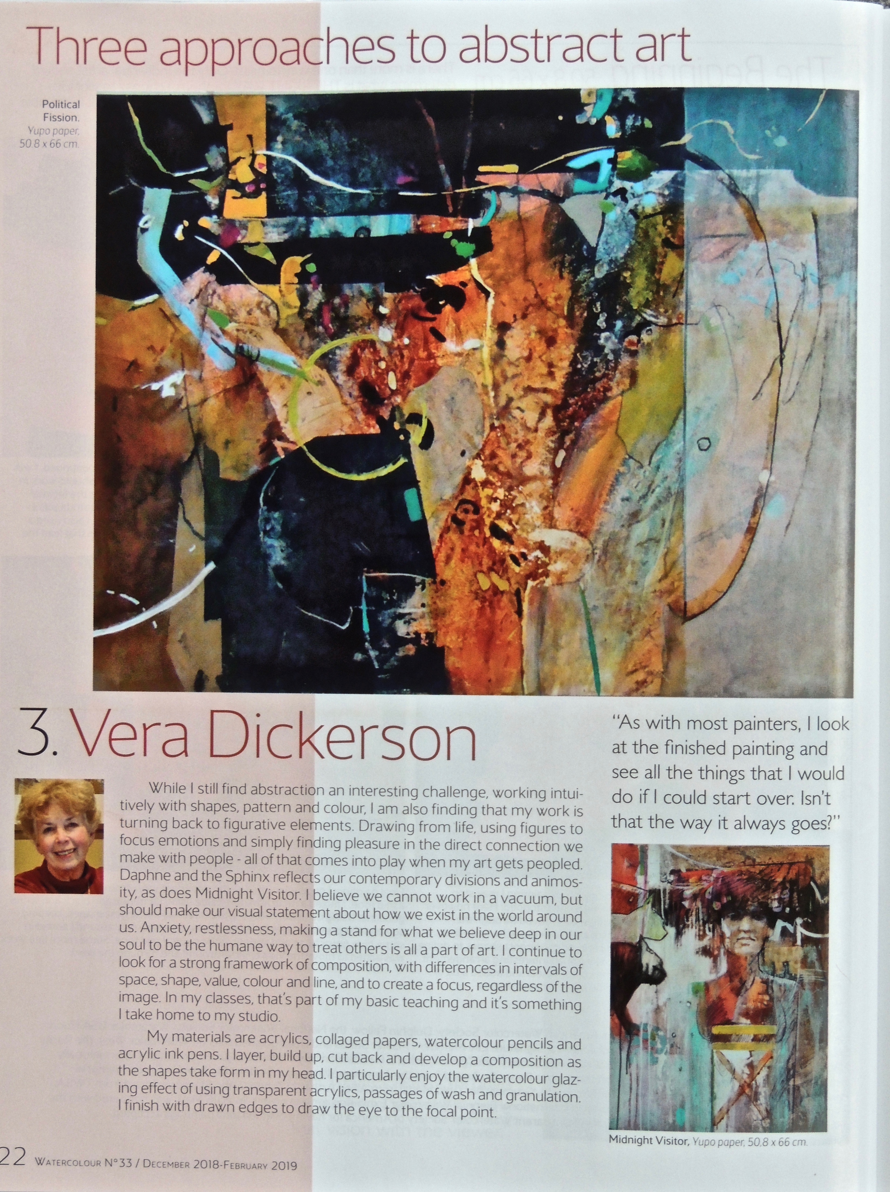
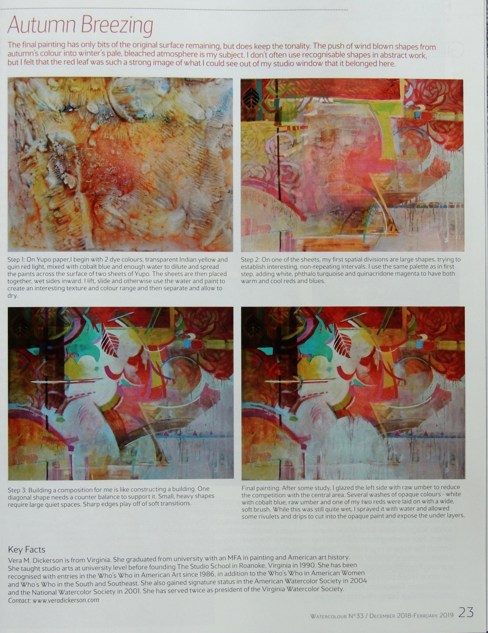
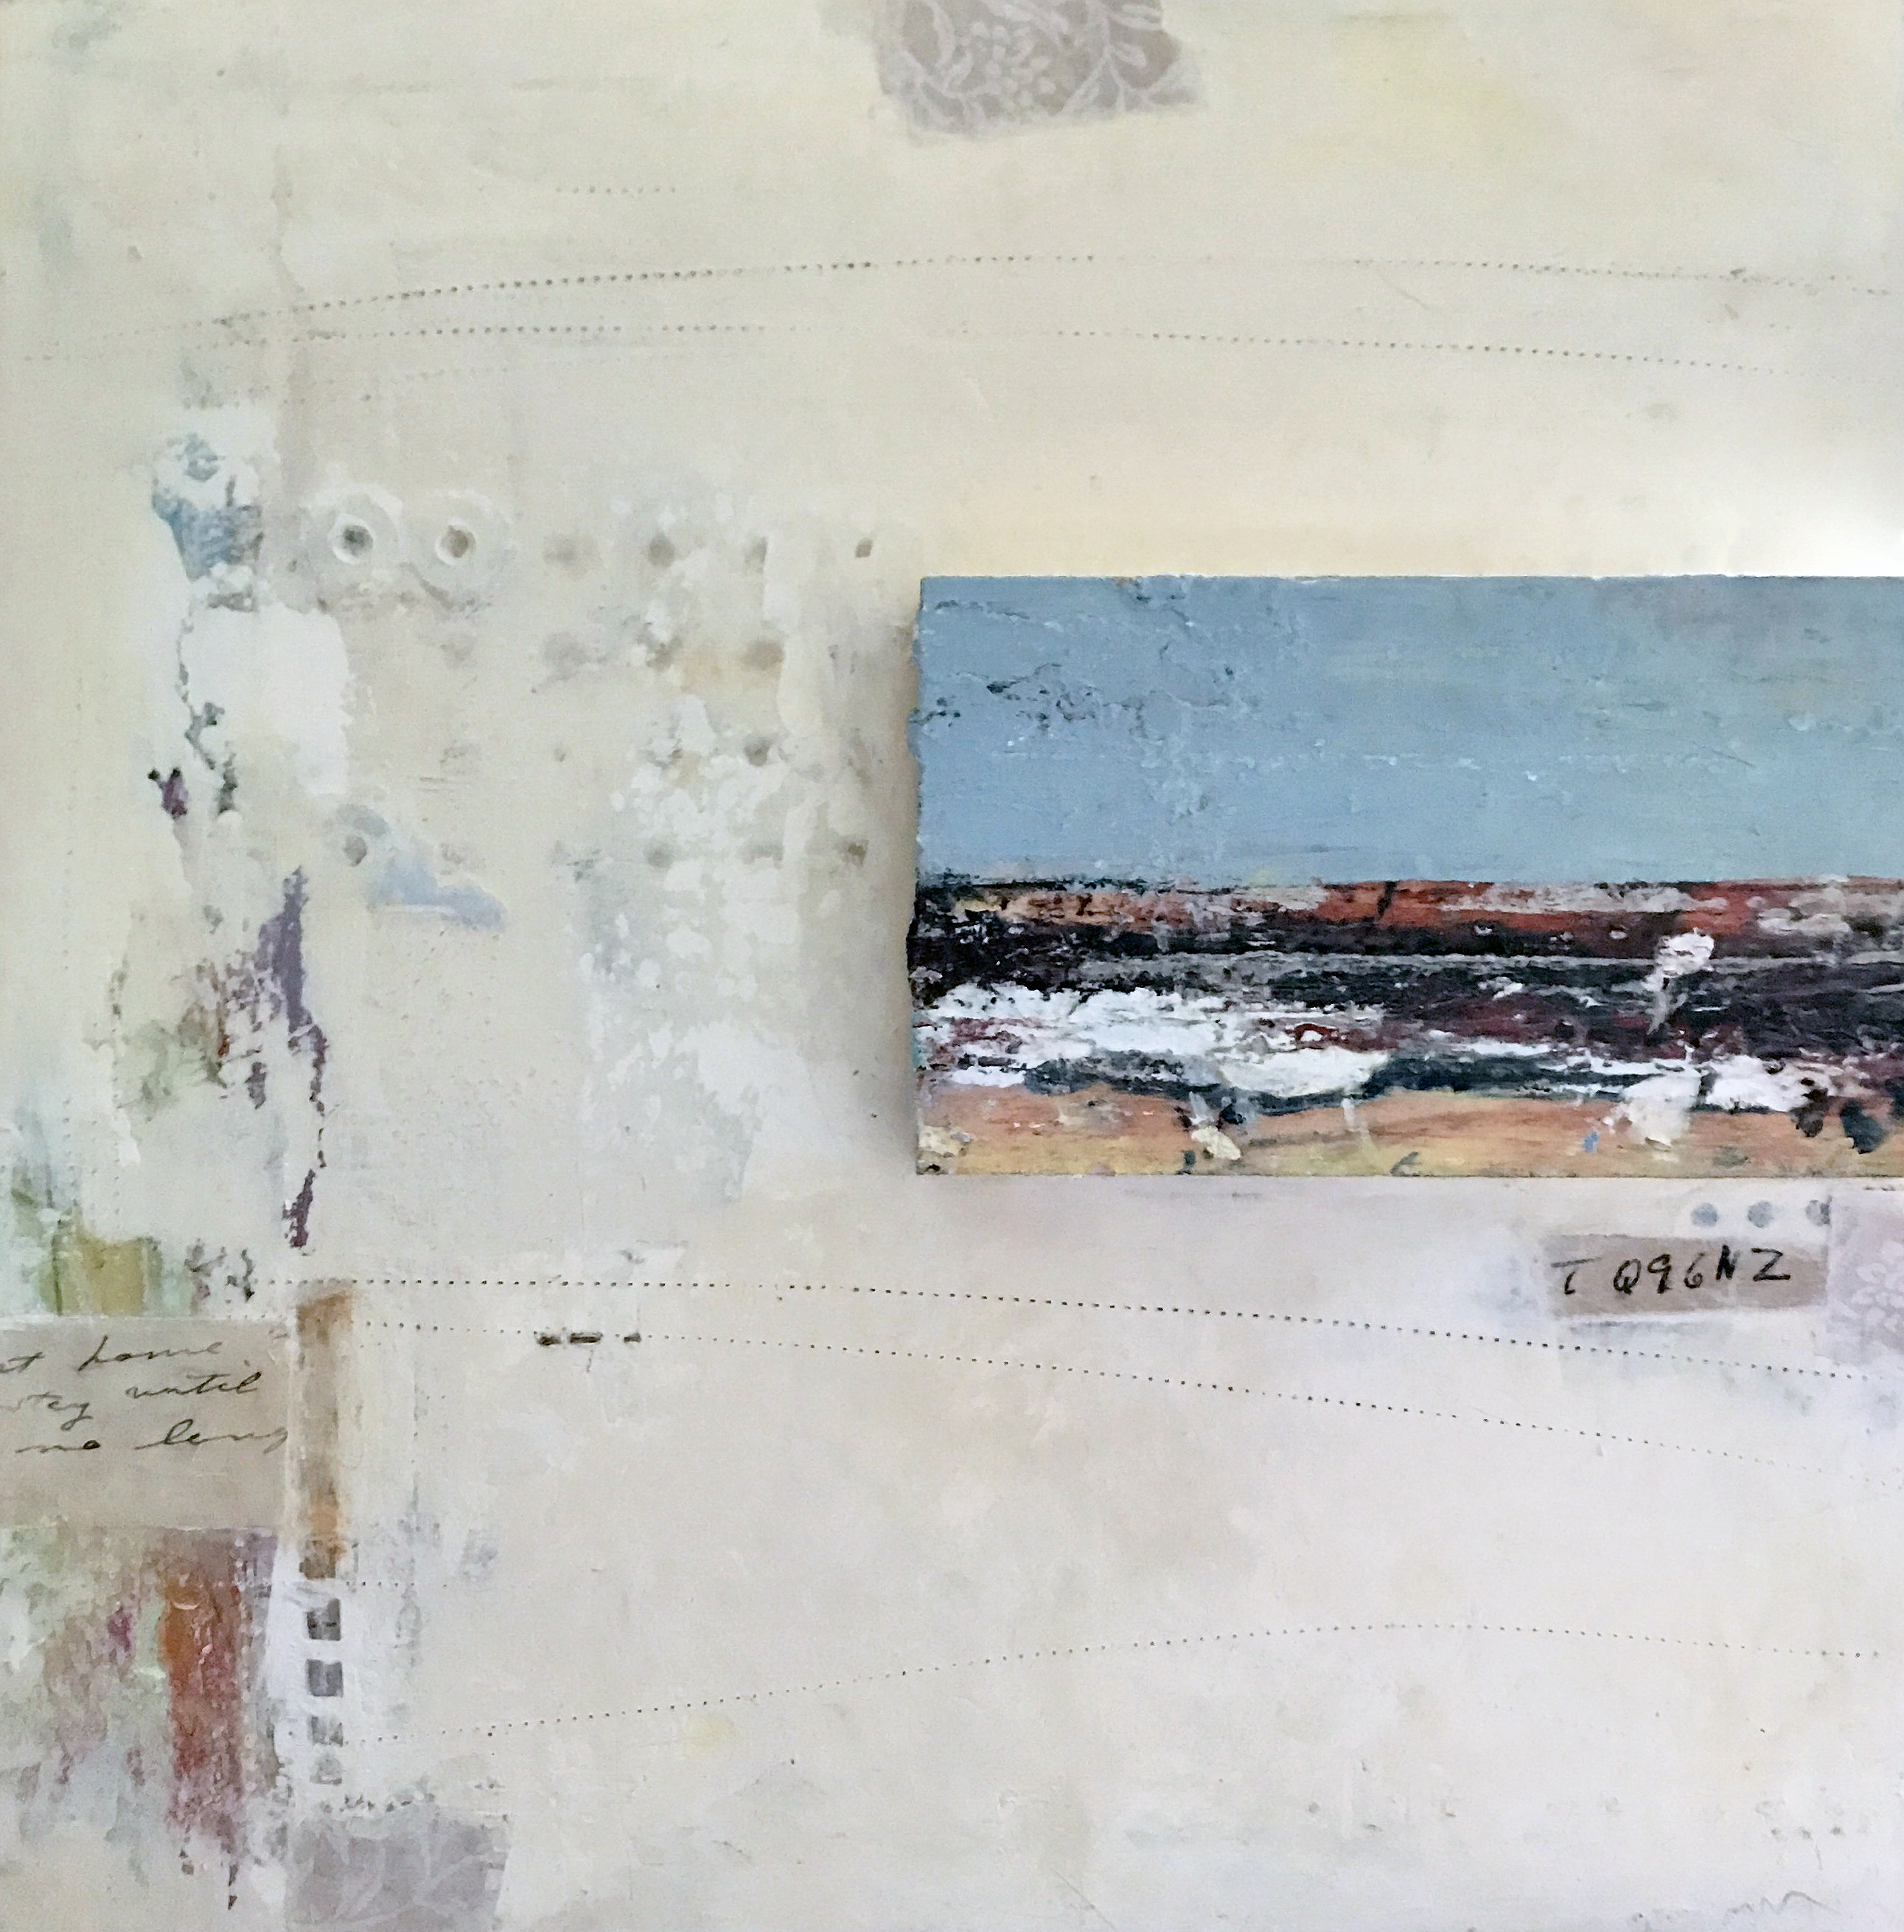
Kudos
Congrats to Vera for her article in the Art of Watercolour, Current English edition. #33. Printed in France, but sometimes available at Barnes and Noble.

Gina Louthian-Stanley will be featured in the next Woven Tale Press magazine and Artemis Journal coming out soon!
Memories of Forgotten Places (C) gls
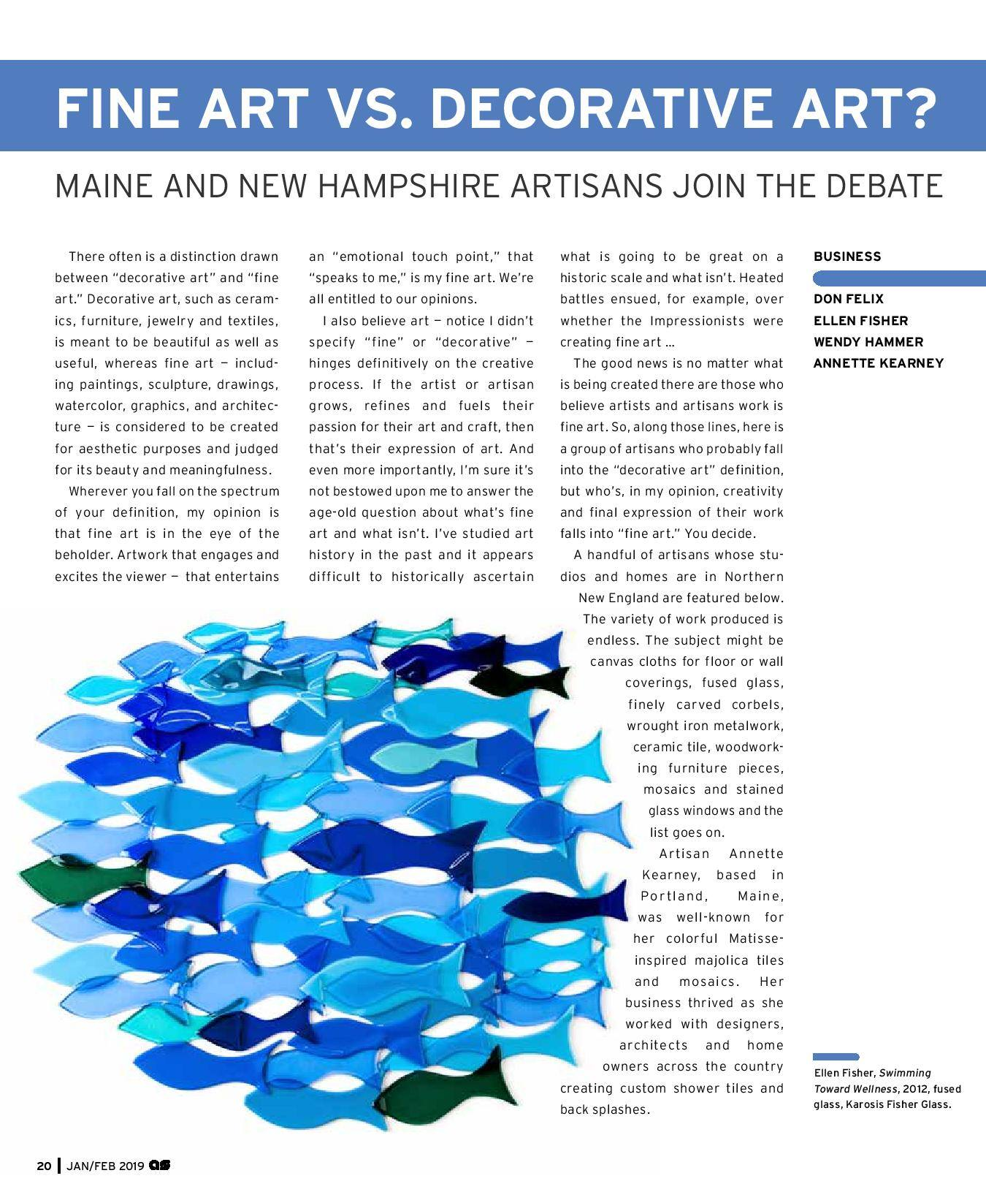
An interesting read, taken from ARTSCOPE MAGAZINE JAN/FEB 2019
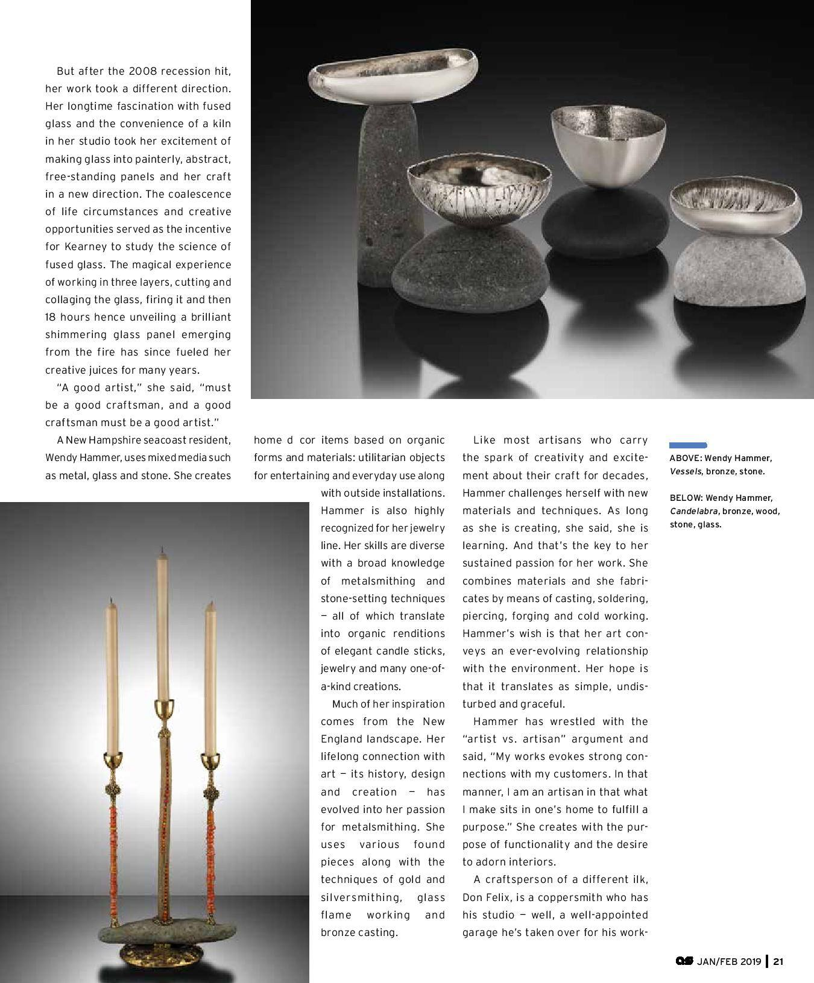
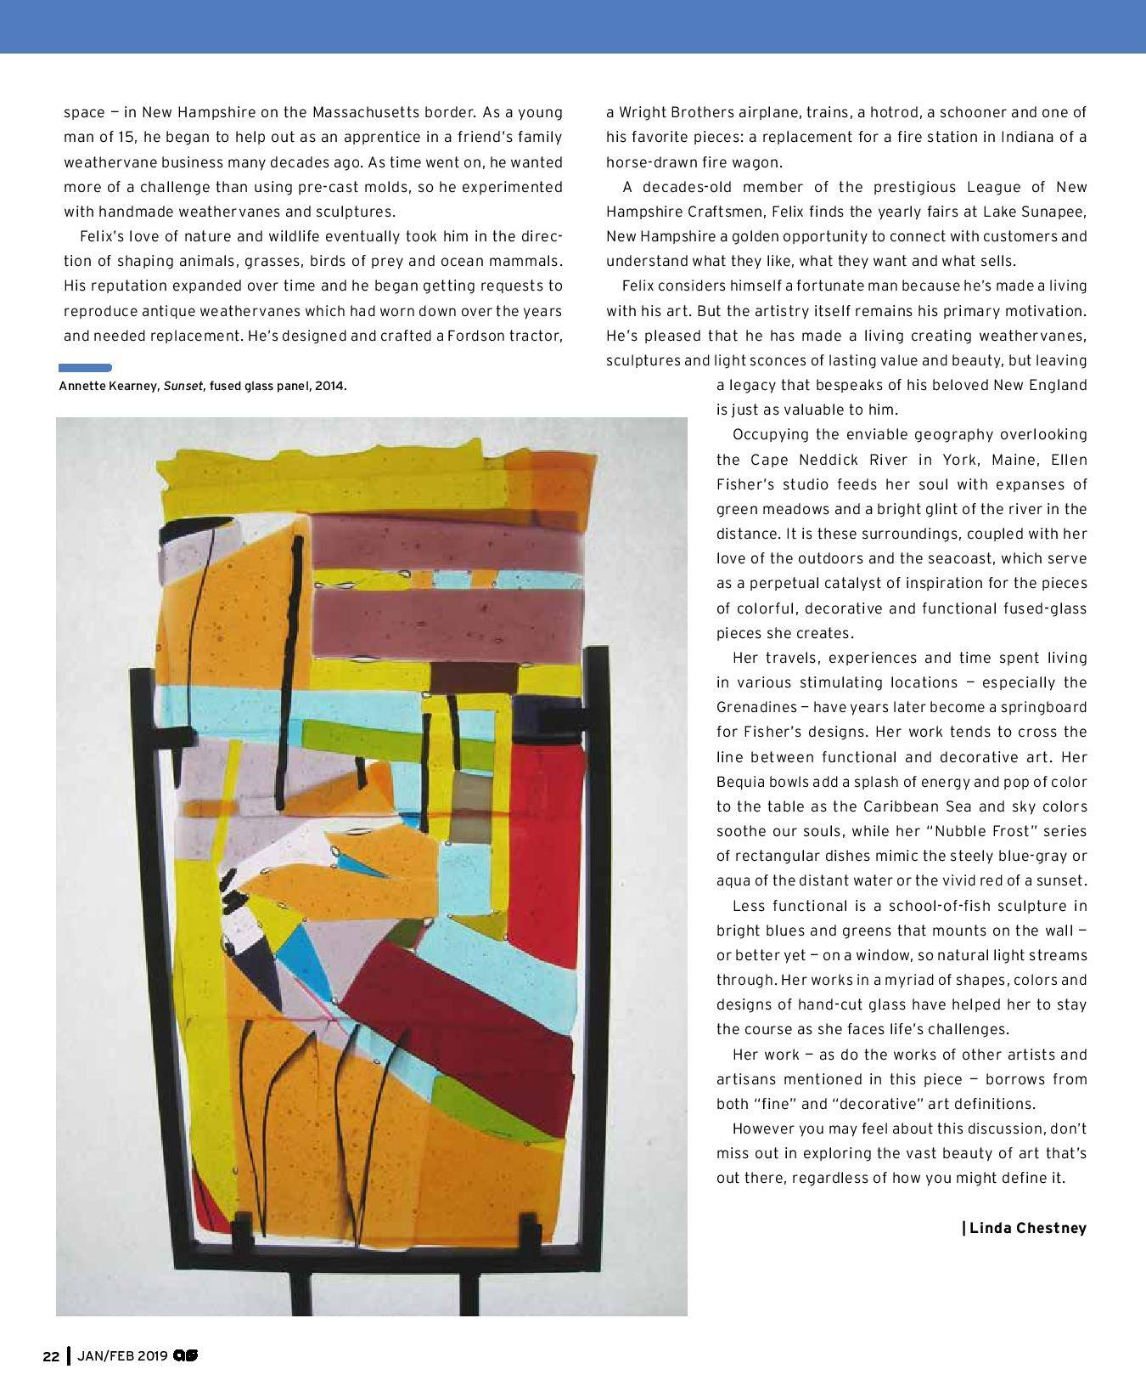
Studio School Summer Workshop 2019

Please join us for a watercolor workshop with Pennsylvania artist Ron Thurston. You can view his paintings at www.ronthurston.net. Dates are Tues. June 25–Fri. June 28. Fee is $380, with a deposit of $180 due upon registration and the balance of $200 due by April 10. Deposits only refunded if there is a waiting list. Easel Society Members may register during the month of Dec. 2018. Everyone else may register after Jan. 1, 2019.
Ron Thurston

I hope it’s true when they say watercolor is the difficult medium. This keeps it exciting and not for everyone. Practicing starts with a stroke of the brush and a follow through, like the strum of a guitar
or the shooting of a basket. My classes begin with the basics of brushes, paints, and paper and
move into that all important design and composition. Watch how your painting, abstract or otherwise, will come alive when the foundation is exciting. Each day different topics will be discussed or demonstrated. Personal expression is encouraged. Lessons are designed to explore color and compositional possibilities to spark ordinary subjects into eye catching visuals. Dive right in.
Ask questions. A casual friendly atmosphere makes the class a fun and rewarding adventure.

Feeling low? Energy flagging? Welcome to the bleakest 31 days of the year.

Overall January is a boring month; it is National Weight Awareness Month, National Oatmeal Month, and typical cold and snowy January in Roanoke. It’s ironic that January kicks off the New Year with celebrations and is a time for self reflection and hope.
New Year’s Day is a time of celebration, filled with traditions that go back 4,000 years. We have parties, special foods, fireworks, resolutions, and since 1907, a large ball that drops in NYC.
In 46 BC, Julius Caesar added two months to the calendar and began the New Year on January 1st to honor its namesake, Janus, the Roman god of new beginnings. Janus had two heads, one looking forward (future) and one looking backward (past).
New Year’s traditions, practiced mostly in the West, have lasted a long time. They are no longer religious so instead of making promises to the gods, we make them to ourselves. Defining resolution as a firm decision to do or not to do something, we resolve to improve ourselves and our life.
2018 was quite a year with our country seriously divided. Perhaps it’s time to embrace another definition of resolution: the action of solving a problem, dispute, or contentious matter. Instead of losing weight as #1, change it to spending more time with people who matter and listening to others.
After reading through lists of resolutions, here are a few more new ones to consider:
•Stop procrastinating
•Meet new people
•Create or join an art critique
•Go for daily walks
•Volunteer and give more to charity
•Take an art class
•Travel more
•Express yourself artistically
•Consider adopting a pet
•Shop locally, support small businesses
Support the arts

After the holidays end, the doldrums set in. Doldrums was once the term used to describe the long difficult journey faced by sailors when there was no wind to push them on their way. Today, we associate the doldrums with the sluggish and depressed feelings we get in the depth of winter when there is nothing to push us on our way.
How to cope? Here are some great suggestions (edited for the art lover):
Exercise – bundle up and go for a walk around your favorite art district
Meet up with friends and do something cheerful like visit your favorite art district
Craving comfort food? Check out special events at your local galleries, they often have great comfort food and a little wine.
Indulge a little, buy something for yourself. What better than art!
Organize, throw out and decorate; sounds like a great time for a new painting or two.
Re-do part of your interior; need some new paintings, sculpture, pottery?
Have friends over, cook something you’ve never made, play in the snow, then sit by the fire and admire your new art.
Of course you can hibernate; binge-watch Netflix; spend the month reading in the bathtub. But whatever you do, don’t crawl back into your hole.
Get out and soak up some sun, schedule some fun and indulge just a little.
311 Gallery, in the heart of Raleigh’s favorite art district, invites you to stop in and indulge yourself. Resident artists have pulled together a great collection of small works that will brighten your day and not empty your pockets.
What a great way to chase the doldrums away!
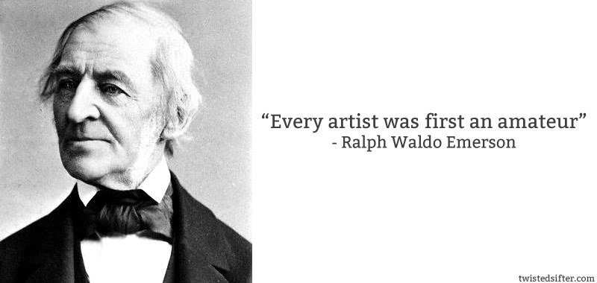
*On Friday. March 8 our Golden rep, Amy Shawley, will come to The Studio School and present a hands on demo of Williamsburg oils.

This is FREE but YOU MUST PREREGISTER. Limit is 25 people.

There is a sign up sheet at school on Tuesday..First 2 weeks are open to Easel Society only, before it becomes open to general public.

If you have attended presentations by Amy in the past, you know what a wealth of information she brings.
__________________________________________________________________________________
*STUDIO SCHOOL AT NORTH CROSS SCHOOL SPRING 2019

You are invited to participate in an exhibit of work by the faculty and students of the Studio School at North Cross School. Exhibit dates will be from March 13 to April 23. Entry forms are due in the envelope below by January 30, 2019.
DELIVERY DATE: MARCH 12 at 9 am. We will begin installing the show at 9:30 am.
PICK UP is April 23 at 9 am. There is an entry fee of $5.00 for one work.
WORKS MUST BE PRESENTATION READY- FRAMED AND WIRED FOR HANGING. GALLERY WRAPS ARE ACCEPTABLE BUT SIDES SHOULD BE PAINTED, WITH NO STAPLES SHOWING.
ALL WORK MUST BE IDENTIFIED WITH THE TAGS PROVIDED BELOW-ONE ON THE FRONT ONE AND ONE SECURELY ATTACHED ON THE BACK, PLUS THE COMPLETED ENTRY FORM. THIS INCLUDES ARTIST’S NAME, TITLE OF WORK, ALL CONTACT INFORMATION AND PRICE OR NFS (NOT FOR SALE). North Cross takes a 25% commission. PLEASE Fill in a W9 form for North Cross, available on line irs.com W9
PLEASE NOTE: PAPERWORK WILL BE DUE JANUARY 30.
Shows and Events:
Artist Opportunities

New Waves 2019 Annual Juried Exhibition
Virginia Museum of Contemporary Art
2200 Parks Ave, Virginia Beach VA 23451 March 23 - August 2019
Entry deadline: January 11
Submissions open November 5
Jan/Feb/Mar 2019

Southern Watercolor Society
42nd Annual Juried
Exhibition
Kerr Arts & Cultural Center
228 Earl Garrett St, Kerrville TX 78028 May 23 - July 6, 2019
Entry deadline: February 19
(must be member of SWS)
Artist Noti cation: March 5
Juror: Judy Morris https://kackerrville.com

7th Annual ART SPEAKS Juried Exhibition
Bay School Community Arts Center
279 Main St, Mathews VA 23109 April 27-May 25, 2019
Entry deadline ( nal): March 1 Early deadline: February 1 Acceptance noti cations: March 12 Juror/Judge: Janly Jaggard
$5k in prize money
Opening reception: April 27, 4-6pm Prospectus: www.bayschool-arts.com/pages/artspeaks

16th Annual VMRC Juried Art Exhibition
Park Gables Gallery
Harrisonburg VA
May 16 - June 30, 2019
Entry deadline: March 15
(via USPS or email) 3 Divisions:
Drawing/Painting/Printmaking Photography/Digital Artworks 3-D/Assemblage/Other Media
Over $6700 in awards Jurors:
Cyndi Gusler Eric Kniss Dietrich Maune
Call for Artists - pdf: https://www.mycommunity-center.com/ lephotos/150/Prospectus20EntryForm2019.pdf
Contact information:
Anne Pauley, Director
1491 Virginia Ave, Harrisonburg VA 22802 540-564-3400
artexhibit@vmrc.org (Preferred) www.vmrc.org/juried-art-exhibition

Danville Festival in the Park
2o19 Fine Art Show
Ballou Park, 760 W Main St
Danville VA
May 17, 18, 19, 2019
Contact Festival in the Park at: brianaleebill@gmail.com
Indoor and Outdoor space available
National Juried Fiber Arts
Exhibition
Bower Center for the Arts
305 N Bridge St
Bedford VA 24523
July 9 - August 17, 2019
Entry deadline: May 1, 2019 Artist noti cations: June 7 Awards reception : July 12, 5-pm Juror/Judge: Jill Jensen
Cash awards
Call for artists is downloadable: www.bowercentger.org

Bower Center 7th Annual National Juried Exhibition
Bower Center for the Arts
305 N Bridge St
Bedford VA 24523
July 9 - October 8 - November 9, 2019 Entry deadline: August 7
Artist noti cations: Sep 14
Juror/Judge: TBA
Cash awards, plus solo exhibit to Best in Show winner
Call for artists will be available early spring
Juror: Carmen Hermo
Opening reception: March 22
$4750 in cash awards
Prospectus: http://www.virginiamoca.org/sites/default/ les/New%20Waves%202019%20Artist% 20Application%20Information.pdf

5th Annual Edna Curry/John
Bower Exhibition
Bower Center for the Arts
305 N Bridge St
Bedford VA 24523
January 29 - March 9m 2019
Entry deadline: January 19
Judge: TBA
Call for artists wil l be available to down- load by mid/late-October www.bowercenter.org
Cash awards, plus solo exhibit to Best in Show winner

Annual Juried Art Exhibition
Academy Center for the Arts
600 Main St, Lynchburg VA 24504 www.academycenter.org
April 5 - 27, 2019
Entry deadline: February 15 Noti cations to artists: March 11 Juror: Joan Huiner Ranzini
Exhibit is normally in April
Prospectus: https://academycenter.org/2019-juried-

